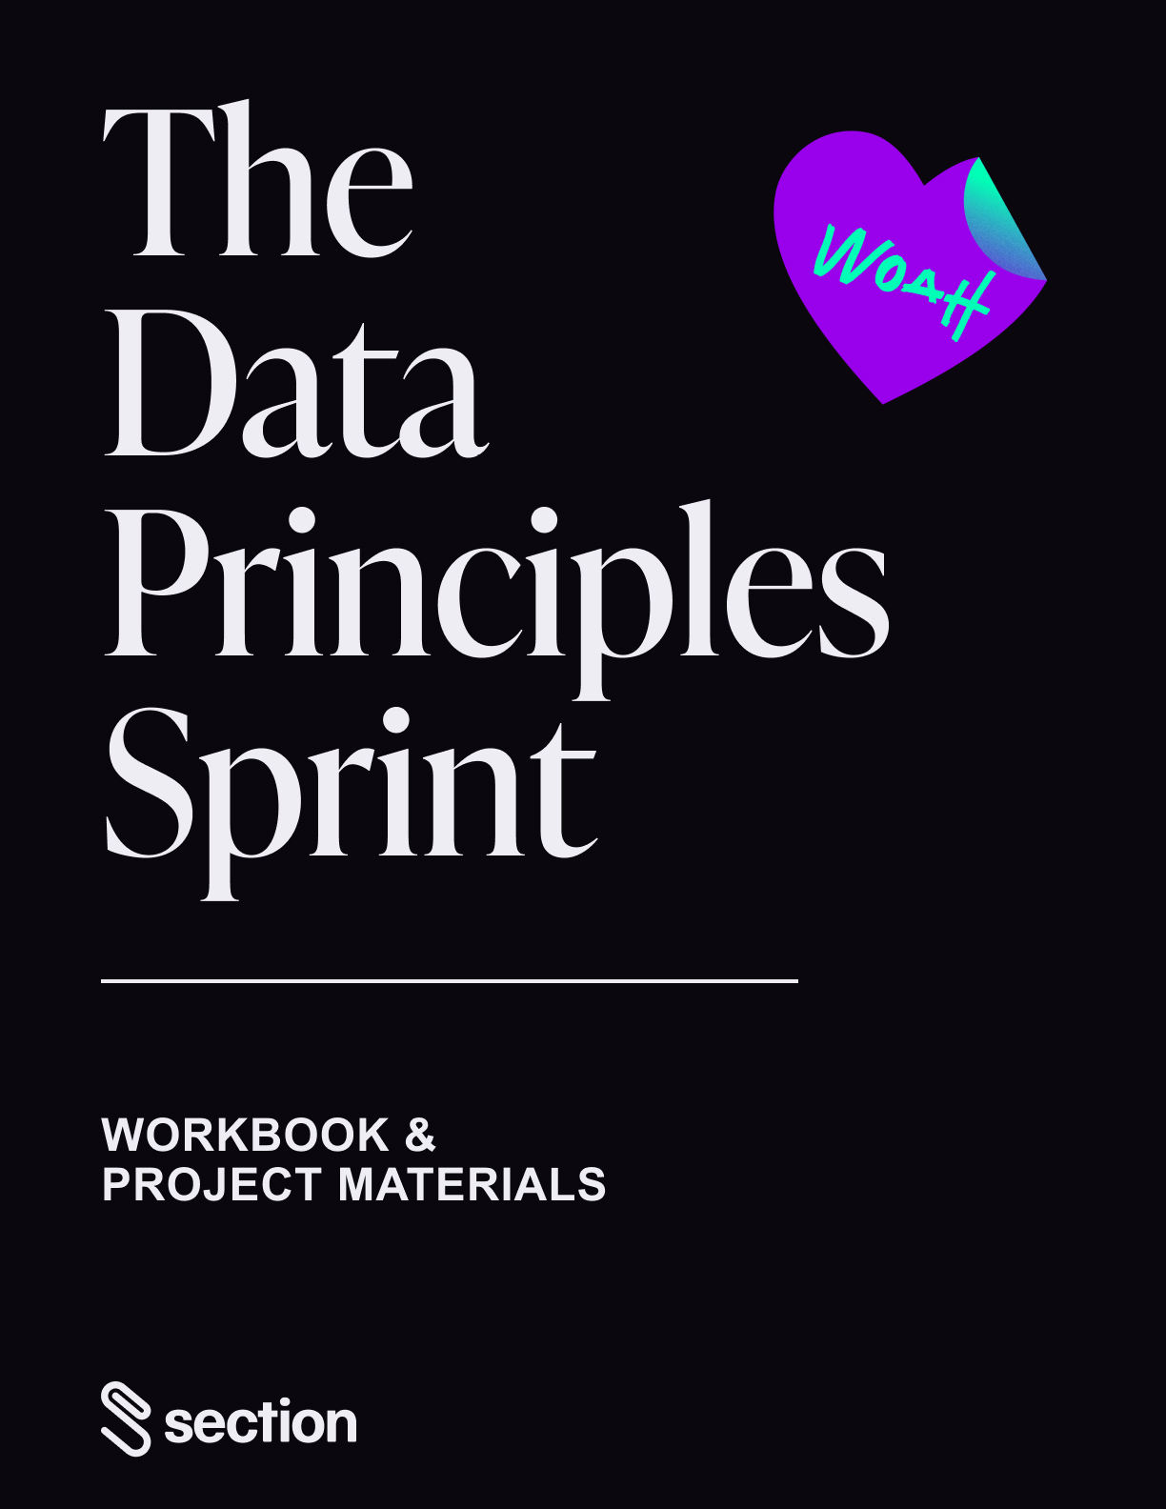

The Data Principles Sprint

Welcome to the Section Data Principles Sprint. We couldn’t be more excited to have you here. Over the next few weeks, you’ll learn how to bring a more analytical lens to your toughest business challenges. The sprint unpacks how to run an analytics project from start to finish, as well the specific strengths analytical leaders use to their advantage and how to develop them at your firm. To get the most out of these materials begin with the following action-items:

* Download this document so you can add your responses, click **“File >   
   Download”** or Copy & Paste into a new document.
* These materials are for you — you won’t be turning these in, so feel free to jot   
   down notes, write in the margins, and make it your own!
* In this project, **we will be providing the dataset and problem** so you can hit the   
   ground running in starting the analytics process. Questhire, a recruiting agency,   
   is beginning to run online ads and would like to better understand which target   
   demographics generate the highest clicks. Design and run a model to generate   
   actionable insights.

After you’ve viewed each module, respond to the **reflection questions and complete the worksheets** in this document.

* The reflection questions help you reflect on the course content in the context of   
   your own company.

Last but not least, head over to your **Slack section** to discuss your thoughts, learnings, and takeaways with your peers.

Your cumulative effort in completing the worksheets means you’ve done the heavy-lifting going into the project. Use the project to translate your insights into actionable recommendations and build a game plan for implementation. To stay on track with your project, check out the “**Project To-Do**” below each set of reflection questions. You’ll turn in the project by Sunday, March 6, to complete the course. The first step? Familiarize yourself with this document and then head over to the [Sprint Center](http://go.section4.com) to get started with Module 1!

# Module 1

**The Power and Process of Analytics**

Raw data is transformed into insights through a process resembling an assembly line.



**Framing the Problem**

Strong analytical problems are untested, defined, acute, testable, actionable, and impactful.

**Q1:** What was a recent decision your firm made that was informed by analytics? If no recent examples come to mind, what’s a decision that could have benefitted from analytics?

**Q2:** Summarize the analytical process that took place or could have taken place:

* What data was analyzed?
* How was the output of the model monitored? Did people and/or software   
   evaluate the results of the model?
* Is there an opportunity at your firm for humans and machines to work together?

**Q3:** What business problems and opportunities are you currently working on? Think about the pains customers, employees, or other stakeholders experience.   
  
**Q4:** In your opinion, is your firm equipped to solve this problem or seize this opportunity with its existing resources and capabilities, or would it require significant investment and training?

**Takeaway:** What's one idea, question, or insight this module prompted that you'd like to discuss with classmates? Tell fellow sprinters in your #section Slack channel.

| 📓 Project to do Keep an eye out for the first Data Practicum Livestream. This will provide practical, hands-on knowledge working directly with datasets and prepare you for success with project materials. |
| --- |

### 

# Module 2



**Exploring and Evaluating Data**

Effective analytics runs on data that is sufficiently sized, reliable, unique, and accessible.



**Designing Models**

Lend your expertise to a model’s design by mapping your problem, hypothesis, variables, and the data to measure them.

**Q1:** Have you heard of a firm that used data creatively to gain an advantage? How did they use this data and why was it unique at the time?

**Q2:** Jot down a list of 7-10 times you create data throughout the day. It could be a survey you complete, a song you listen to, or an issue you log at work.

**Q3:** What business challenge is top of mind at the moment? If you had to venture a guess, what do you think are the most important variables?

**Q4:** What measurements would indicate you’ve solved your challenge? What measurements would comment on whether or not your guess was correct?

**Takeaway:** What's one idea, question, or insight this module prompted that you'd like to discuss with classmates? Tell fellow sprinters in your #section Slack channel.

| 📓 Project to do Complete **Worksheet 1**. You’ll be provided with a dataset and problem. Contextualize and understand your data prior to designing your model.   1. Explore and contextualize the QuestHire dataset to understand the data you are working with. What type of data are you looking at? 2. Design a model. |
| --- |

### Worksheet 1: Design a Model

#### Project Directions

QuestHire, a recruiting agency, has just hired a new content marketing manager to run and optimize online ads. Lucy Brown, the new content marketing manager would like to make data-driven decisions and better understand which target demographics generate the highest clicks for QuestHire’s Facebook ad campaigns. This will inform if QuestHire is appropriately reaching their target audience age group of 30-34. To analyze this problem, the firm provided you with a [dataset](https://docs.google.com/spreadsheets/d/1D1BV0F8kndKKr9Jjx_jHeWNVzdS4vWz-Kk1cN2Yvg-Y/edit?usp=sharing). Your job is to create a hypothesis related to the problem and fill in the Analytics Blueprint below.

See a sample solution for 4Store here.

| **Analytics Blueprint** | | |
| --- | --- | --- |
| **Problem**  Fill in the problem or opportunity. | Which target demographics generate the highest clicks for Questhire’s online Facebook ad campaigns? | |
| **Hypothesis**  Compose a hypothesis — an educated guess about the factors that significantly shape the outcome you’re studying. | Hypothesis:   * Specific *(clearly indicates the factors you believe influence an   outcome)* * Falsifiable *(hypothesis can be confirmed or refuted)* | |
| **Dependent Variable**  List the dependent variable that represents the outcome of your problem and one data source to measure it. | Dependent Variable:  Data Source: | |
| **Independent Variables**  List two independent variables — the factors you believe best predict the outcome. | Independent Variable #1 | Independent Variable #2 |
| **Data Points**  Name 1 variable from the dataset to measure each of your independent variables. | Data Source #1 | Data Source #1 |

# Module 3



**Interpreting Results**

Interpret results more objectively by asking three structured questions:

* Does this confirm or refute my hypothesis?
* How confident am I in the model?
* Do I understand correlation vs. causation?

**Q1:** What major shifts has your industry experienced in the last few years? Were they expected or unexpected shifts? If a shift was unexpected, why did they catch your industry off guard?

**Q2:** Are there correlations that your firm commonly accepts as to how consumers behave? For example, the majority of greeting cards are purchased within two days of a holiday?

**Takeaway:** What's one idea, question, or insight this module prompted that you'd like to discuss with classmates? Tell fellow sprinters in your #section Slack channel.

| 📓 Project to do Complete **Worksheet 2.** Now that you’ve created a hypothesis and designed a model, let’s put it to the test.   1. Leverage pivot tables and “cut” the data in different ways to notice patterns and run your model. 2. Interpret your results by asking yourself additional structured questions. |
| --- |

#### 

### 

### Worksheet 2: Running your model and interpreting results

#### Directions

Use the dataset provided in Step 1 to analyze and run your model. Then, take notes and interpret your results to think of next steps.

Tips for running your model:

* Create a pivot table
* Measure by both sums and averages
* Aggregate calculations for your independent variable by different levels of detail,   
   including your dependent variables and check for patterns
* Create new calculations that create a new variable based on existing variables in   
   the dataset
* Visualize your data in a simple way

See a sample solution for 4Store here.

| **Running Your Model** | |  |
| --- | --- | --- |
| Notes on Results | |  |

#### 

| **Interpreting Results** | | |
| --- | --- | --- |
| Do the results confirm or refute your hypothesis? |  | |
| What insights did you gain from the results even if your hypothesis was refuted?  Are there actionable next steps that can be taken based on the new insight? |  | |

### 

# Module 4



**Competing on Analytics**

The D.E.L.T.A. model capabilities distinguish firms that wield a strategic advantage with analytics: Data, Enterprise Strategy, Leadership, Targets, and Analysts.

**Q1:** Which of the D.E.L.T.A. capabilities does your firm excel at? Why?

**Q2:** Which of the D.E.L.T.A. capabilities does your firm have the greatest room for improvement? Why? What are some actions you can take in the near future to improve this capability at your organization?

**Takeaway:** What's one idea, question, or insight this module prompted that you'd like to discuss with classmates? Tell fellow sprinters in your #section Slack channel.

| 📓 Project to do Begin work on presenting your data insights in a format of your choosing. Make sure you’ve finished the pre-work by completing your worksheets. |
| --- |

### 

# Final Project: QuestHire

Every leader benefits from bringing a more analytical lens to their toughest business challenges. To that end, you can use Professor Davenport’s frameworks to bring a quantitative mindset to your toughest challenges.

#### Project Directions

QuestHire, a recruiting agency, has just hired a new content marketing manager to run and optimize online ads. Lucy Brown, the new content marketing manager would like to make data-driven decisions and better understand which target demographics generate the highest clicks for QuestHire’s Facebook ad campaigns. This will inform if QuestHire is appropriately reaching their target audience age group of 30-34. To analyze this problem, the firm provided you with a [dataset](https://media.sectionschool.com/courses/the-data-principles-sprint/QuestHire_Facebook_Ad_Campaign_Data.xlsx).

#### Project Pre-Work

If you haven’t already, complete the pre-work for this project:

1. Complete **Worksheet 1** to compose a hypothesis and design a model for the QuestHire dataset and problem you have been provided with.
2. Complete **Worksheet 2** to run your model and interpret the results.

#### Project Resources

* [QuestHire Facebook Ad Campaign Data](https://media.sectionschool.com/courses/the-data-principles-sprint/QuestHire_Facebook_Ad_Campaign_Data.xlsx)

#### Project Output: Propose Next Steps

Reflect on your results in **Worksheet 2**. Create a proposal that articulates next steps for QuestHire based on the insights that have been uncovered from your model.

Some pro tips to keep in mind:

* **Clearly outline the steps that need to be taken:** Have a bias toward action - what is an immediate action QuestHire should take. Or what additional opportunities and problems should QuestHire analyze?
* **Show evidence for your recommendation:**  Share your results and interpretation to support your claims in a manner that lends itself to be clearly understood to QuestHire’s marketing team.

**Choose a Delivery Format**

In terms of delivery, you can share your recommendations in a slide deck, Amazon-style memo, landing page, short video, or whichever method best delivers your message. Short slide decks, sub-five minute videos, and two-pagers are your best bet.

**Upload Your Project**

To submit your final project, complete the course, and sign up to get peer feedback, upload your work to the Sprint Center. We provide certificates of completion and LinkedIn badges to students who complete this course — this includes watching all the sprint videos and turning in this project.

We look forward to seeing what you come up with!

# Worksheet 1: Design a Model (4Store Sample Solution)

4Share, an office supply company, offers a wide range of products. The company is interested in analyzing its orders and sales to answer which product subcategories accounted for the majority of growth in revenue from 2014-2017. This will provide insight on which products to further promote or which products to remove from its catalog.

See 4Store sample dataset [here](https://docs.google.com/spreadsheets/d/1iJAZb6zrfFfsyCgnSuHHn2NkmzQjbUOI/edit#gid=185230788).

| **Analytics Blueprint** | | |
| --- | --- | --- |
| **Problem** | *Which product subcategories account for the majority of growth in revenue from 2014-2017?* | |
| **Hypothesis**  Compose a hypothesis — an educated guess about the factors that significantly shape the outcome you’re studying. | *Phones within the technology product category, accounted for the majority of growth in revenue from 2014-2017*  ☑Specific *(clearly indicates the factors you believe influence an outcome)*  ☑Falsifiable *(hypothesis can be confirmed or refuted)* | |
| **Dependent Variable**  List the dependent variable that represents the outcome of your problem and one data source to measure it. | Dependent Variable: *Revenue*  Data Source: *“Sales”* | |
| **Independent Variables**  List two independent variables — the factors you believe best predict the outcome. | Independent Variable #1  *PRODUCT SUBCATEGORY* | Independent Variable #2  *YEAR* |
| **Data Points**  Name 1 variable from the dataset to measure each of your independent variables. | Data Source #1  *‘PRODUCT SUB-CATEGORY*’ | Data Source #1  *‘YEAR‘* |

#### 

#### 

# Worksheet 2: Running your model and interpreting results (4Store Sample Solution)

#### Directions

Use the dataset provided in Step 1 to analyze and run your model. Then, take notes and interpret your results to think of next steps.

See 4Store sample project [here](https://media.sectionschool.com/courses/the-data-principles-sprint/4Store_Project_Example.pdf).

Tips for running your model:

* Create a pivot table
* Measure by both sums and averages
* Aggregate calculations for your independent variable by different levels of detail,   
   including your dependent variables) and check for patterns
* Create new calculations that create a new variable based on existing variables in   
   the dataset
* Visualize your data in a simple way

| **Running Your Model** | |  |
| --- | --- | --- |
| Notes on Results | | * growth was calculated by subtracting 2014 sales from 2017 sales (growth = 2017 sales - 2014 sales) * however, growth can be defined and calculated in varying methods including cagr = compound annual growth rate * copiers account for the highest dollar growth from 2014-2017. accessories, binders, phones account for the next highest dollar growth in sequential order * machines provided the lowest dollar growth, going into the negatives |

#### 

| **Interpreting Results** | | |
| --- | --- | --- |
| Do the results confirm or refute your hypothesis? | * the results refuted the hypothesis that phones had the highest growth in revenue from 2014 - 2017. although phones were among the top product subcategories, copiers by far experienced the highest dollar growth. * machines is a product subcategory within technology products but did not experience growth in revenue | |
| What insights did you gain from the results (even if your hypothesis was refuted)?   Are there actionable next steps that can be taken based on the new insight? | * even if a product category is doing well, if you cut the data a level deeper there may be subcategories within a category performing at varying levels * based on revenue growth by product subcategories, 4store can take steps to further promote high revenue generating products and consider removing low performing product subcategories | |

### 